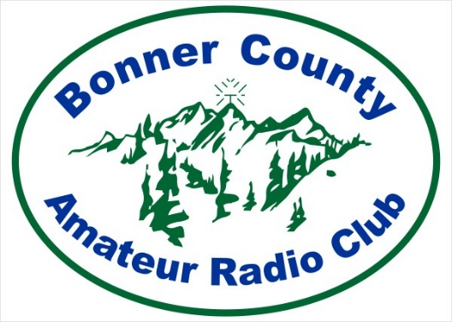
Bonner County Amateur Radio Club
PO Box 792
Ponderay, ID 83852-0792
www.K7JEP.org
email: K7JEP@arrl.net

2025 Annual Meeting Minutes
VFW Hall, Sandpoint, Idaho
January 8, 2025, 6:30 pm

- 6:30 pm - Meeting called to Order by current president, John Ailport

- Quorum declared by club secretary Ken Conradi, 20 of 69 members present – 29% present, 25% required

- 2024 Financial Review by acting Treasurer, Vern Walters. Financial report was approved by unanimous vote of all members present

- John Ailport presents slate of candidate officers for vote:

Daryl Baird, President
John Kludt, Vice President
Vern Walters, Treasurer
Ken Conradi, Secretary

- Motion to approve vote, Motion seconded, Candidates approved by unanimous vote of all members present

- Remarks by President Elect, Daryl Baird and award to outgoing President, John Ailport

- Motion to adjourn annual meeting, motion seconded, approved by unanimous vote

