BCARC Board Meeting AGENDA
August 14, 2024 @ 1700
Sandpoint VFW Hall

Board Members: John Ailport, Pat Cox, Ken Conradi, Jim Morford

NOTE: There was not a quorum for this meeting, only John and Ken were in attendance. No formal meeting was held and no official discussions were had.

Club Members Present:

1) July minutes.

2) Administrative

- BoD meetings before Club monthly meeting. We lose an entire month after the BoD meeting to address any items at the Club meeting. Are we OK with this and if not, do we want to reschedule BoD meetings? How and when?
- Current bank balances - See treasurer spreadsheet –
- Help Wanted – still need greeter(s). Also need backup for Simplex net
- BoD officer elections – Do we want to put together a nominating committee to talk to folks who are potentially interested in a BoD position? This would look more like a real election. Who might be interested in participating on a committee; probably need at least 2 people.

3) 2024 Field Day

- After action meeting or discussion? How best to do this (if were going to?)

4) Planned Club events for remainder of 2024 per Johnnys email
- We dropped a couple of events because nobody has stepped up to coordinate and run them:
Transmitter Hunt
POTA activation/BBQ
- Do we want to try and form an Activities Committee to coordinate some of the proposed activities?

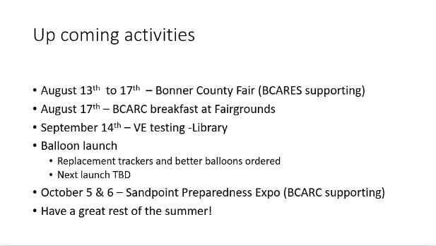

Gentlemen,

As we round out the year I have couple of questions outside of the meeting programs:
- I am assuming that we will repeat the holiday get together in December. That means no formal program. It also means we should probably recognize a couple of folks who stepped up last year. Ken you didn't read this but I would suggest recognition go to Colleen. She has taken the newsletter to a whole new level. She put up with a lot of "pressure" trying to manage Field Day - basically unmanageable task the way BCARC works. We should probably recognize one or at most two more individuals. Too many year end awards and it becomes meaningless. Your ideas?
- We are trying to get balloon #2 in the air. Do we have a target date for that?
- We had talked about Fox Hunt #2 - I really would appreciate some help with this. Again, do we have a target date? I am guessing September/early October before the chance of snow increases.
- We have casually talked about a POTA type event. If a formal POTA, who will be the activator, submit the log, etc.? If just "Go Boxes in a Park" it is a much easier thing to organize. Having said that, who is going to organize it, where will we go, when, etc.?

One unfortunate thing of having Exec meetings just before the club meeting is there is no time, like zero, to organize decisions for presentation to the club without losing what amounts to another month. And winter is just around the corner.

Respectfully,

John K7SYS

5) New Business or topics for future discussion

- Bylaw workgroup/review Ken will organize this with a couple other members. Results will be presented to the BoD for review. Approved changes will be voted on at a special club meeting or the 2025 Annual Meeting. NO PROGRESS

6) Secretary noted that 2023 Taxes done. Questioned whether these should be done by Treasurer in the future. BoD agreed
they should. Secretary needs to transfer info to Treasurer. NO PROGRESS

7) Make summary sheet that notes admin tasks and costs
State registration
Federal Taxes
ARRL Insurance
Groups.io
Zoom

Secretary volunteered to do a draft of this. NO PROGRESS

8) Other items?

Urgent items to be addressed at tonight’s general membership meeting at 1800?

- ??
- ??
- ??

Meeting adjourned @

